SURVEY DATA ANALYSIS TOOL
Student Social Media Usage, Digital Dependency & Well-being.
A Project Report Submitted in the partial fulfillment of the requirements for the award of the degree of

BACHELOR OF TECHNOLOGY
In

DEPARTMENT OF COMPUTER SCIENCE OF ENGINEERING
By
SriHansika Saraf-2420030556
R.Jahnavi-2420030173
T.Mounitha-2420030330

Under the Esteemed Guidance of

B Prathusha
Assistant Professor
Department of CSE

AY-2026-2027

Semester: Odd Semester




K L (Deemed to be) University
DEPARTMENT OF COMPUTER SCIENCE OF ENGINEERING

Declaration

The Project Report titled “SURVEY DATA ANALYSIS TOOL: Student Social Media Usage, Digital Dependency & Well-being” is a record of the bona fide work of SriHansika Saraf (2420030556), R. Jahnavi (2420030173), and T. Mounitha (2420030330), submitted in partial fulfillment of the requirements for the award of the Bachelor of Technology (B.Tech.) degree in Computer Science and Engineering at K L University. The results embodied in this report have not been copied from any other department, university, or institute.

SriHansika Saraf-2420030556
R.Jahnavi-2420030173
T.Mounitha-2420030330

K L (Deemed to be) University DEPARTMENT OF COMPUTER SCIENCE OF ENGINEERING

CERTIFICATE

This is certify that the mini project based report entitled “SURVEY DATA ANALYSIS TOOL: Student Social Media Usage, Digital Dependency & Well-being” is a bonafide work done and submitted by SriHansika Saraf (2420030556), R. Jahnavi (2420030173), and T. Mounitha (2420030330)in partial fulfillment of the requirements for the award of the degree of BACHELOR OF TECHNOLOGY in Department of CSE, K L (Deemed to be University), during the academic year 2026-2027.

Signature of the Guide

Signature of the Course Coordinator Signature of the HOD

ACKNOWLEDGEMENT
The success in this project would not have been possible but for the timely help and guidance rendered by many people. Our wish to express my sincere thanks to all those who has assisted us in one way or the other for the completion of my project.

Our greatest appreciation to my Course Coordinator Nalajala Sunanda, and my guide B Prathusha, Department of CSE which cannot be expressed in words for his/her tremendous support, encouragement and guidance for this project.

We express our gratitude to Dr. P.Venkateshwar Sir, Head of the Department for CSE for providing us with adequate facilities, ways and means by which we are able to complete this project-based Lab.

We thank all the members of teaching and non-teaching staff members, and also who have assisted me directly or indirectly for successful completion of this project. Finally, I sincerely thank my parents, friends and classmates for their kind help and cooperation during my work.

SriHansika Saraf-2420030556
R.Jahnavi-2420030173
T.Mounitha-2420030330

Abstract
The Survey Data Analysis Tool is a Python-based Data Science project that collects, processes, analyses and visualises survey responses to identify meaningful patterns in students' social media usage behaviour. The primary dataset is a Google Forms/Sheets survey of 400 student responses covering 28 questions on platforms, daily usage time, checking habits, study distraction, sleep, stress and well-being. Two Kaggle datasets (a social media addiction dataset and a student lifestyle dataset) are inspected and integrated as secondary, contextual references.

The project follows an end-to-end workflow: Data Collection, Data Inspection and Integration, Preprocessing, Exploratory Data Analysis (EDA), Statistical Analysis (descriptive statistics, correlation, covariance, Chi-square and hypothesis tests), Feature Engineering, Feature Selection, Machine Learning, Dashboard and Insights. Sixteen new features were engineered, including a Digital Dependency Score and a Social Media Impact Score, and a three-class target (Low, Moderate, Heavy social media user) was derived from the reported daily usage time. Twelve features were selected using mutual information and random-forest importance; the daily usage time itself was excluded to prevent target leakage.

Five classifiers (Logistic Regression, Decision Tree, Random Forest, K-Nearest Neighbours and Support Vector Machine) were trained on an 80/20 stratified split and compared using accuracy, precision, recall, F1-score and confusion matrices. Logistic Regression performed best, with 56.25% accuracy and a weighted F1-score of 51.60% on the 80-record test set; no model identified the minority 'Heavy' class reliably, and none of the Chi-square or hypothesis tests showed a statistically significant association at the 5% level. These results are reported as obtained, without artificial improvement. The findings are presented through an interactive Streamlit dashboard with survey statistics, visualisations, statistical findings, model comparison and a prediction page that classifies a student as a Low, Moderate or Heavy user. Because the survey data contains simulated responses in addition to the originally submitted response, the results demonstrate the complete workflow and should not be read as population-level statistics.

Keywords: Survey analysis, Social media usage, Data preprocessing, Exploratory data analysis, Chi-square test, Classification, Logistic Regression, Streamlit.

Index
S. No. | Chapters | Topics | Page.no
 |  | Acknowledgement
 |  | Abstract
1 | Introduction | 1.1 Background of the project  1.2 Problem statement  1.3 Scope of the project  1.4 Objective(s)  1.5 Importance of the application  1.6 Target users/audience | 1-3
2 | System Requirements | 2.1 Hardware requirements  2.2 Software requirements  2.3 Development tools and frameworks | 4-5
3 | Technology Stack | 3.1 Front-end (Streamlit)  3.2 Back-end (Python processing modules)  3.3 Database (file-based storage)  3.4 Version Control  3.5 APIs or External services | 6-7
4 | System Architecture | 4.1 High-level architecture diagram  4.2 Description of each layer (frontend, backend, database)  4.3 Deployment architecture (e.g., cloud, local, CI/CD pipelines) | 8-9
5 | Design | 5.1 Wireframes or mockups  5.2 ER Diagram / Database schema | 10-12
6 | Implementation | 6.1 Module-wise implementation  6.2 Front-end logic (UI rendering, state management)  6.3 Backend logic  6.4 Database connectivity  6.5 API integration  6.6 Authentication & Authorization | 13-21
7 | Features | 7.1 List of main features  7.2 How each feature works (user perspective + technical description) | 22-23
8 | Testing | 8.1 Functional testing (Postman not applicable)  8.2 Integration testing  8.3 Tools used for testing  8.4 Test cases and results | 24-25
9 | Deployment | 9.1 Steps to deploy  9.2 Environment configuration  9.3 Hosting of frontend and backend | 26-27
10 | Challenges & Limitations | 10.1 Issues faced during development  10.2 Solutions applied  10.3 Current limitations or known bugs | 28-29
11 | Future Enhancements | 11.1 Planned features  11.2 Possible integrations or optimizations | 30
12 | Conclusion | 12.1 Summary of the project  12.2 What was achieved  12.3 Skills learned during development | 31
13 | References | - Books, tutorials, APIs, documentation sites used | 32
14 | Appendices | 14.1 Screenshots of the app  14.2 Sample code snippets  14.3 Installation/setup instructions  14.4 User manual or guide  14.5 Certifications | 33-34

CHAPTER 1
Introduction
1.1 Background of the project
Social media platforms such as Instagram, YouTube, WhatsApp and Snapchat have become part of the daily routine of college students. They are used for communication, entertainment, learning and social interaction, but long or poorly timed use may also affect study habits, sleep, stress and overall well-being. Understanding how students actually use these platforms is therefore of interest to students, teachers, counsellors and researchers.
Surveys are the most common way of collecting this kind of information. A survey, however, produces raw responses: text categories such as 'Sometimes' or '2–3 hours', inconsistent spellings, personal identifiers and answers that cannot be used directly in statistics or machine learning. Turning these responses into reliable insight requires a repeatable Data Science workflow: collecting the data, cleaning it, exploring it, testing relationships statistically, building predictive models and presenting the results in a form that non-programmers can read.
The Survey Data Analysis Tool implements this workflow for a survey on student social media usage, digital dependency and well-being. It is written in Python and uses Pandas, NumPy, Matplotlib, Seaborn, SciPy and Scikit-learn for processing, analysis and modelling, and Streamlit for the interactive dashboard.
1.2 Problem statement
Survey responses on social media behaviour are collected in raw, text-based form and spread over many questions. Analysing them by hand is slow and error-prone, patterns across questions are easy to miss, and there is no simple way to test whether apparent relationships (for example between usage time and academic performance) are statistically meaningful or to classify a student's overall usage level from their behaviour. There is a need for a tool that automatically cleans survey data, analyses it statistically, trains and compares classification models, and presents the findings in an understandable dashboard.
1.3 Scope of the project
Included in the scope:
• A primary dataset of 400 student survey responses (28 questions) collected through Google Forms/Sheets.
• Two secondary Kaggle datasets (social media addiction, 20 records; student lifestyle, 2,000 records), inspected and organised in an integration workbook for contextual reference.
• Data inspection, integration, preprocessing, exploratory data analysis, statistical analysis, feature engineering and feature selection.
• Classification of students into Low, Moderate and Heavy social media users using five machine learning algorithms, with model comparison and selection of the best model.
• An interactive Streamlit dashboard showing survey statistics, visualisations, statistical findings, machine learning results and a prediction page.
Outside the scope:
• Real-time or automatic collection of survey responses; the survey is exported from Google Sheets and processed in batch.
• Causal conclusions, clinical or psychological diagnosis of social media addiction.
• Generalising the results to the whole student population (see Section 10.3).
• A Power BI dashboard, which was proposed in the project abstract; the dashboard was built in Streamlit instead.
1.4 Objective(s)
1. To collect and organise survey data on students' social media usage from a Google Sheets survey and supporting Kaggle datasets.
2. To clean and preprocess the data: handle missing values, duplicates, inconsistent text and personal identifiers.
3. To perform exploratory data analysis of demographics, platforms, daily usage time, checking behaviour, study distraction, sleep and well-being.
4. To apply statistical analysis (descriptive statistics, correlation, covariance, Chi-square tests and hypothesis tests) to examine relationships between variables.
5. To engineer meaningful behavioural features and select the most informative ones without target leakage.
6. To train, evaluate and compare classification models that classify students as Low, Moderate or Heavy social media users, and select the best model.
7. To present the results in an interactive dashboard that also allows a new student profile to be classified.
1.5 Importance of the application
• Automation: the same scripts can be re-run when new responses are added, removing repetitive manual work in spreadsheets.
• Statistical validity: relationships are tested with significance tests rather than judged from charts alone, which helps avoid over-interpreting patterns.
• Methodological care: the project excludes the daily-usage-time column from the model inputs because it directly defines the target, fits preprocessing only on training data, and reports results exactly as obtained.
• Accessibility: the dashboard lets users without programming knowledge explore the findings and try the prediction page.
• Learning value: it demonstrates the complete Data Science workflow from raw data to insight on a real-world topic.
1.6 Target users/audience
• Students and course instructors reviewing a complete Data Science workflow.
• Educators, counsellors and college administrators interested in students' digital habits (as an indicative, not diagnostic, tool).
• Researchers and survey designers who need a reusable pipeline for cleaning and analysing questionnaire data.
• Learners of Python, statistics and machine learning.
CHAPTER 2
System Requirements
2.1 Hardware requirements
The project works on small tabular data (400 survey rows), so no special hardware is needed. The configuration below is sufficient to run all pipeline scripts and the dashboard.
Table 2.1 Hardware requirements
Component | Minimum | Recommended
Processor | Dual-core, 2.0 GHz (Intel Core i3 / AMD Ryzen 3 or equivalent) | Quad-core, 2.5 GHz or higher (Core i5 / Ryzen 5)
Memory (RAM) | 4 GB | 8 GB
Storage | 1 GB free disk space | 2 GB free (Python environment, outputs and models)
Display | 1366 × 768 | 1920 × 1080 (for the wide dashboard layout)
Network | Needed only to install packages, access Google Forms/Sheets and download Kaggle data | Broadband connection

2.2 Software requirements
Table 2.2 Software requirements
Software | Purpose
Operating system: Windows 10/11, Linux or macOS | Runs Python and the dashboard (the project paths are built with os.path and are platform independent)
Python 3.9 or later | Programming language for all pipeline modules and the dashboard
Pandas, NumPy | Data loading, cleaning, transformation and numerical computation
Matplotlib, Seaborn | Charts for EDA, model comparison and the dashboard
SciPy | Chi-square test, t-test, correlation and covariance
Scikit-learn | Feature selection, preprocessing pipelines, five classifiers and evaluation metrics
openpyxl | Reading and writing Excel (.xlsx) files
Joblib | Saving and loading the trained model pipelines (.pkl)
Streamlit | Interactive web dashboard
Web browser (Chrome, Edge or Firefox) | Viewing the dashboard and filling in the Google Form survey
Microsoft Excel or LibreOffice Calc | Viewing the generated .xlsx result files (optional)

2.3 Development tools and frameworks
• Google Forms / Google Sheets: survey design and response collection.
• Python scripts (src/ folder): ten modules, one per stage of the workflow, executed one after another.
• Scikit-learn Pipeline and ColumnTransformer: keep imputation, scaling and encoding inside the training process to avoid data leakage.
• Streamlit: framework used to build the dashboard (streamlit/app.py) in pure Python.
• Code editor / IDE: any Python editor such as VS Code or PyCharm [team to confirm the editor actually used].
CHAPTER 3
Technology Stack
The project is a data-analysis application rather than a conventional client–server web application, so the layers of the usual technology stack are mapped as follows: Streamlit as the front-end, Python modules as the back-end, files as the database, and Google Forms/Kaggle as external data sources.
3.1 Front-end (Streamlit)
The user interface is a Streamlit application (streamlit/app.py, about 1,100 lines). Streamlit turns a Python script into an interactive web page without HTML, CSS or JavaScript. The application uses a wide page layout, a sidebar radio menu with six sections (Overview, Survey & EDA, Statistical Analysis, Machine Learning, Prediction, Final Insights), metric cards, data tables, Matplotlib charts, sliders, drop-down lists and a button for the prediction page. Data and the trained model are loaded once and cached with @st.cache_data and @st.cache_resource so pages respond quickly.
3.2 Back-end (Python processing modules)
The back-end consists of ten Python modules in the src/ folder. Each module reads the output of the previous stage, performs one task and writes its results as Excel and text files.
Table 3.1 Back-end modules
Module | Task | Main output
data_​inspection.py | Inspects shape, data types, missing values, duplicates of all three datasets | outputs/00_​Data_​Inspection
data_​integration.py | Organises the survey and Kaggle datasets in one workbook with a variable mapping | data/interim/Integrated_​Data.xlsx
preprocessing.py | Standardises column names, removes the Name column, cleans timestamp, age and text values | data/processed/Cleaned_​Data.xlsx
eda.py | Exploratory analysis of demographics, platforms, usage, sleep, well-being and bivariate relations | outputs/02_​EDA
statistical_​analysis.py | Descriptive statistics, Spearman correlation, covariance, Chi-square and hypothesis tests | outputs/03_​Statistical_​Analysis
feature_​engineering.py | Creates 16 numeric/binary features and the Low/Moderate/Heavy target | data/processed/Feature_​Engineered_​Data.xlsx
feature_​selection.py | Ranks features by mutual information and random-forest importance; selects 12 | data/processed/ML_​Ready_​Data.xlsx
machine_​learning.py | Trains five classifiers in preprocessing pipelines and saves them | models/*.pkl, outputs/06_​Machine_​Learning
model_​evaluation.py | Ranks models and selects the best one by weighted F1-score | outputs/07_​Model_​Evaluation
final_​results.py | Collects final insights and predictions for the dashboard | outputs/08_​Final_​Results

3.3 Database (file-based storage)
The project does not use a database server. All data is stored in files organised in a fixed folder structure, which is sufficient for a dataset of 400 records and keeps the project portable.
Table 3.2 Storage structure
Folder | Content | Format
data/raw | Original survey export and two Kaggle datasets (never modified) | .xlsx, .csv
data/interim | Integration workbook (5 sheets) | .xlsx
data/processed | Cleaned_​Data, Feature_​Engineered_​Data, ML_​Ready_​Data | .xlsx
outputs/00 … 08 | Result tables, summaries, confusion matrices and classification reports of each stage | .xlsx, .txt
models | Five trained scikit-learn pipelines | .pkl (Joblib)

3.4 Version Control
The project is organised as a plain folder structure that can be placed under Git and hosted on GitHub, which would allow the scripts to be tracked and shared between the three team members [team to add the repository link / confirm Git was used].
3.5 APIs or External services
• Google Forms / Google Sheets: used to design the questionnaire and collect responses; the sheet is exported to Excel for analysis.
• Kaggle: source of two public datasets used as contextual references.
• No REST API is exposed or consumed. The trained model is loaded directly from a .pkl file inside the Streamlit application.
CHAPTER 4
System Architecture
4.1 High-level architecture diagram
Figure 4.1 shows the layered architecture of the system, and Figure 4.2 shows the sequence of processing stages with the size of the data after the main steps.
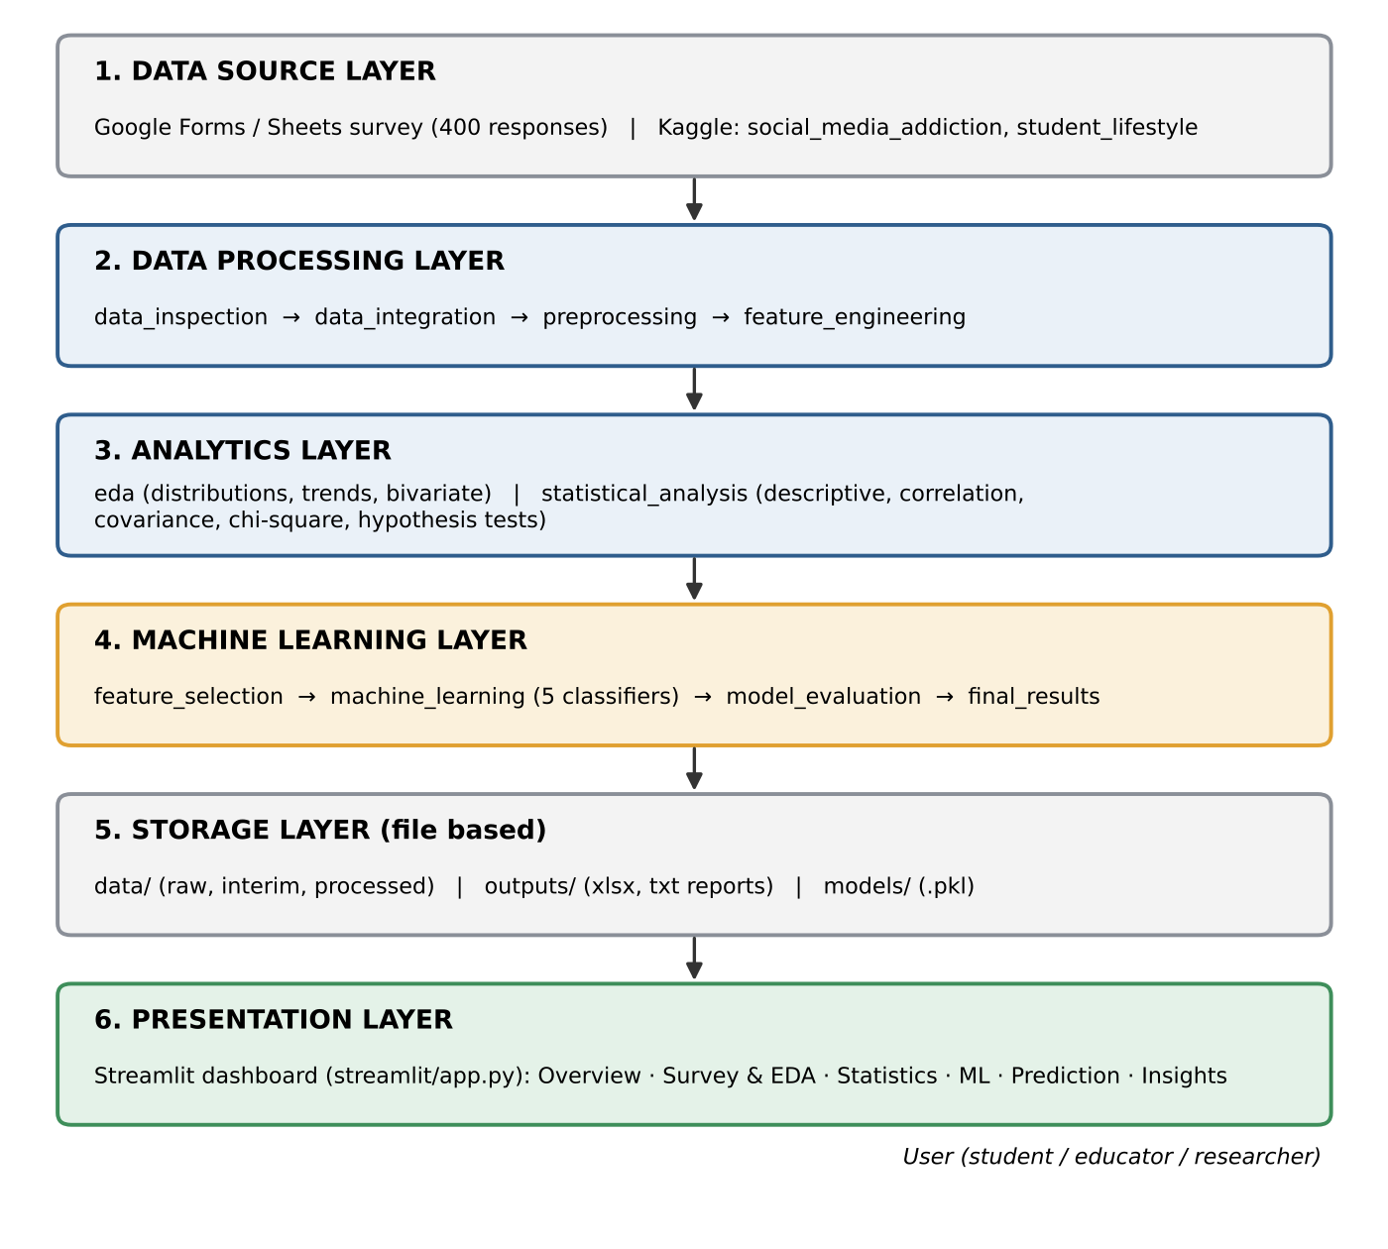
Fig No. 4.1 High-level architecture of the Survey Data Analysis Tool
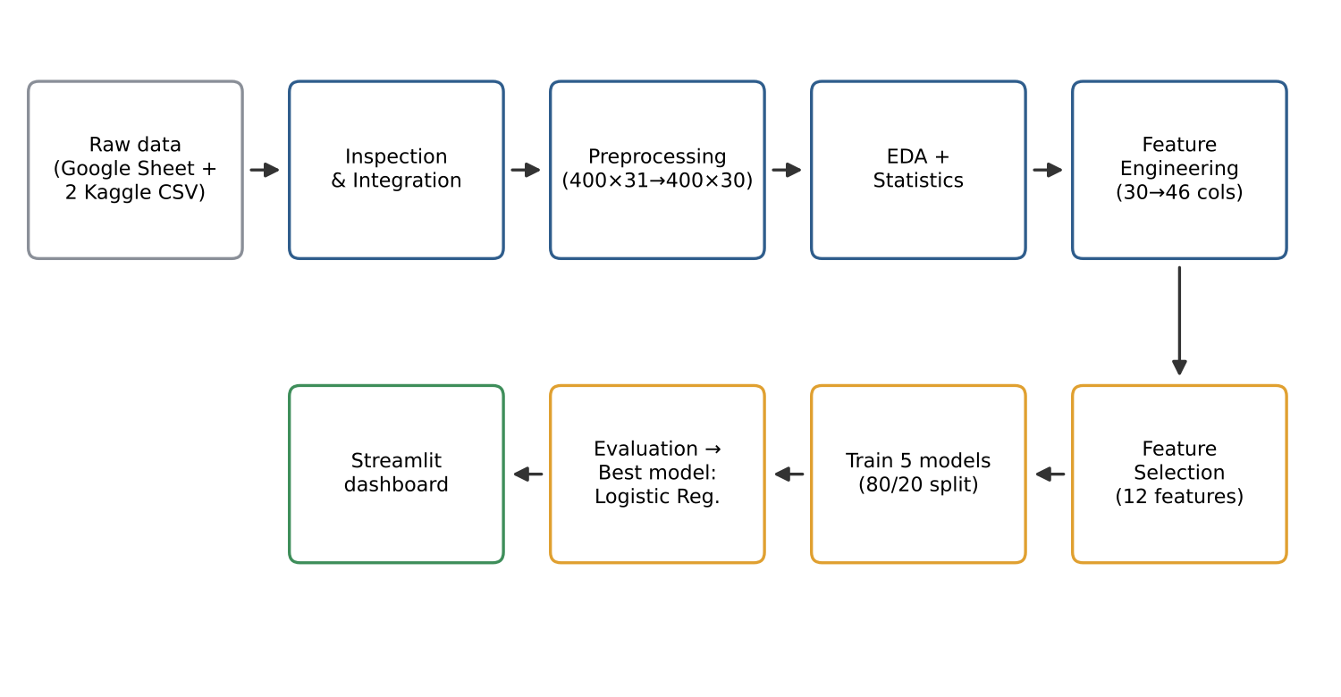
Fig No. 4.2 End-to-end workflow from raw data to dashboard
4.2 Description of each layer
• Data source layer: the Google Forms survey (400 responses, the primary dataset) and two Kaggle CSV files. Raw files are never modified.
• Data processing layer: inspection, integration, preprocessing and feature engineering. The three datasets have different schemas and describe different observations, so they are organised side by side in one workbook rather than blindly concatenated; the survey is the primary dataset.
• Analytics layer: EDA and statistical analysis operate on the cleaned survey data and write Excel summaries.
• Machine learning layer: feature selection, training of five classifiers, evaluation and selection of the best model; trained pipelines are saved as .pkl files.
• Storage layer: the data/, outputs/ and models/ folders described in Section 3.3.
• Presentation layer: the Streamlit dashboard reads the processed data, result workbooks and saved model, and presents them in six sections.
4.3 Deployment architecture
The system runs locally on a single computer. The pipeline scripts are executed once in order to (re)generate all outputs and models, and the dashboard is then started with the Streamlit command. No cloud services, containers or CI/CD pipelines are used at present; hosting options are discussed in Chapter 9.
CHAPTER 5
Design
5.1 Wireframes or mockups
The dashboard has a fixed sidebar for navigation and a main area that changes with the selected section. The wireframes below are schematic layouts of the dashboard structure.
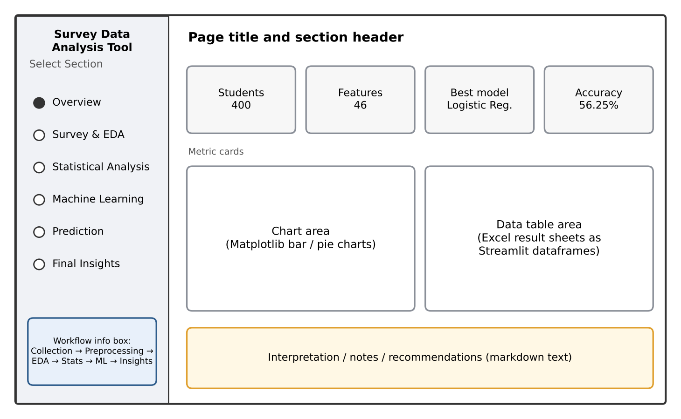
Fig No. 5.1 Wireframe of the dashboard layout (sidebar navigation and main area)
The Prediction page contains twelve input controls (the twelve features used by the model), a prediction button and a result area. The result is shown as a colour-coded banner (green for Low, orange for Moderate, red for Heavy) together with the class probabilities.
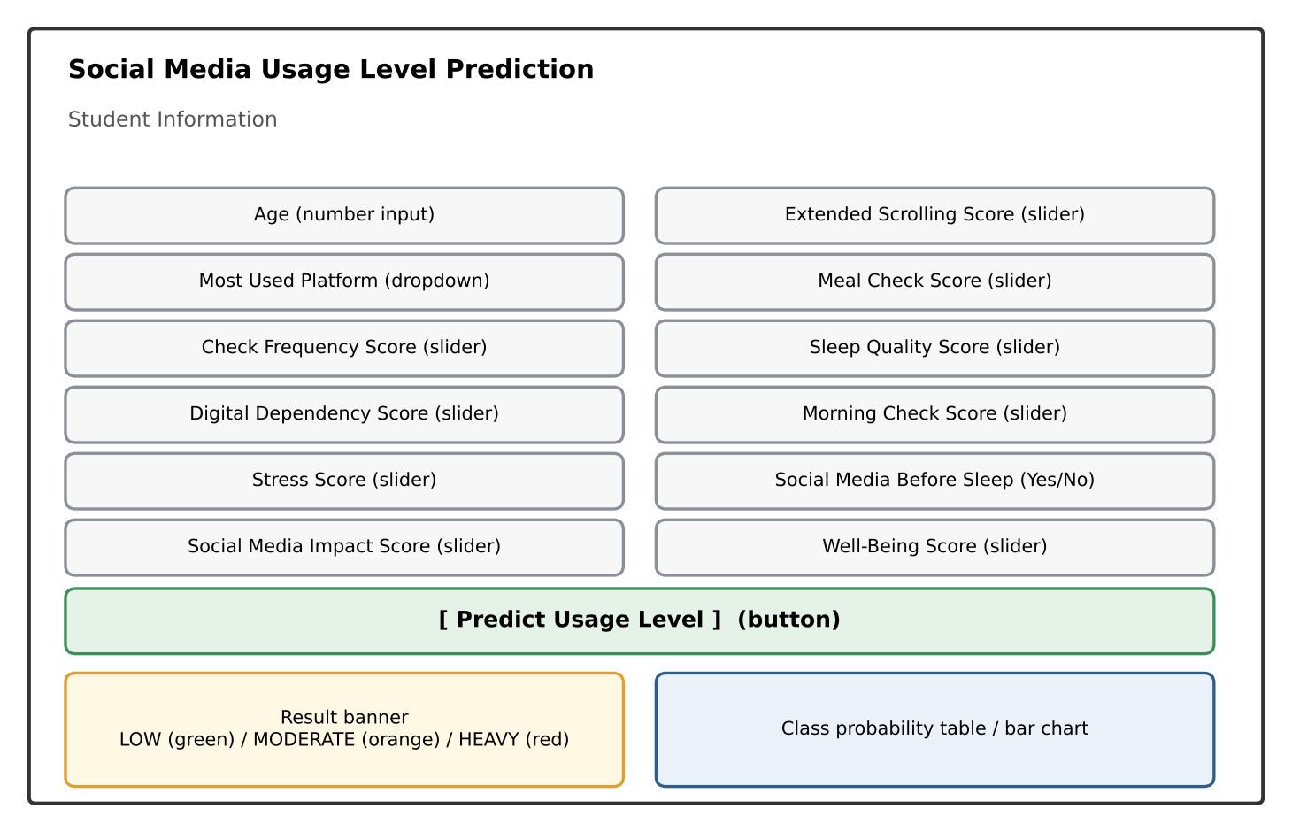
Fig No. 5.2 Wireframe of the Prediction page
Table 5.1 Dashboard sections
Section | Contents
Overview | Project description, key metrics, usage-level distribution and workflow
Survey & EDA | Dataset overview, platform, daily usage, academic performance, sleep quality, well-being and cleaned data table
Statistical Analysis | Descriptive statistics, correlation, covariance, hypothesis tests and Chi-square tests
Machine Learning | Model comparison table and accuracy chart, best model, target class distribution
Prediction | Input form and predicted usage level with probabilities
Final Insights | Key findings, best model, selected features and recommendations

5.2 ER Diagram / Database schema
Because the data is stored in files, the 'schema' is the structure of the workbooks and how each one is derived from the previous one (Figure 5.3). Table 5.2 describes the final ML-ready dataset, which is the input of all models.
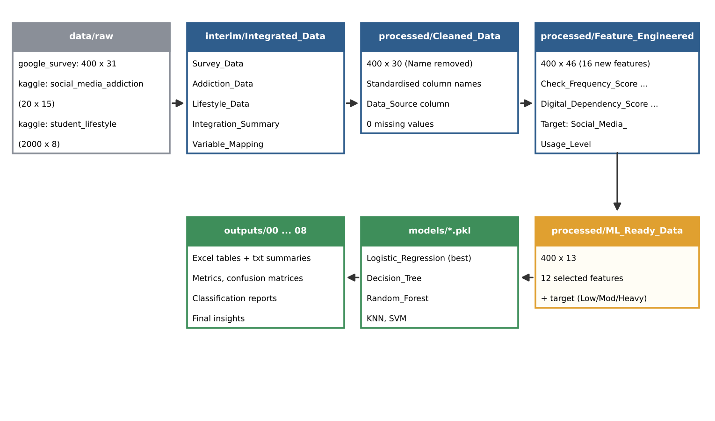
Fig No. 5.3 Data lineage and file schema of the project
Table 5.2 Schema of ML_Ready_Data.xlsx (400 rows × 13 columns)
Column | Type | Description
Check_​Frequency_​Score | Ordinal (1–4) | How frequently the student checks social media (Rarely … Always)
Digital_​Dependency_​Score | Numeric (0.5–3.75) | Mean of check-frequency, app-check count, morning check, meal check, extended-scrolling and discomfort scores
Stress_​Score | Ordinal (0–4) | Stress caused by social media use (Never … Always)
Social_​Media_​Impact_​Score | Numeric (0–4) | Mean of study distraction, stress, mood, comparison, discomfort, wish-to-reduce and scrolling scores
Age | Integer (17–24) | Age of the student
Extended_​Scrolling_​Score | Ordinal (0–4) | Continuing to scroll longer than planned
Meal_​Check_​Score | Ordinal (0–4) | Checking social media during meals
Most_​Used_​Platform | Categorical | Instagram, YouTube, WhatsApp, Snapchat, Facebook, LinkedIn, Telegram, X (Twitter)
Sleep_​Quality_​Score | Ordinal (0–4) | Self-rated sleep quality (Very Poor … Very Good)
Morning_​Check_​Score | Ordinal (0–4) | Checking the phone immediately after waking up
Social_​Media_​Before_​Sleep_​Binary | Binary (0/1) | Uses social media within 30 minutes before sleep
Well_​Being_​Score | Ordinal (0–4) | Self-rated overall well-being (Very Poor … Very Good)
Social_​Media_​Usage_​Level | Target (Low / Moderate / Heavy) | Derived from the reported daily usage time

CHAPTER 6
Implementation
6.1 Module-wise implementation
6.1.1 Data collection
The survey 'Student Social Media Usage' was created in Google Forms and the responses were stored in Google Sheets. After cleaning, the survey has 400 responses, 28 questions (30 columns including the timestamp and a data-source label), covering: demographics (age, gender, year of study); platforms and most-used platform; daily usage time; checking frequency and number of daily app checks; reason for use; use while studying, study distraction and delayed work; academic performance; sleep duration, sleep before bed and sleep quality; stress, mood, social comparison and discomfort without access; wish to reduce use; overall well-being; morning and mealtime checking; extended scrolling; attempts to reduce use and satisfaction.
The respondents' ages range from 17 to 24 (mean 20.44, standard deviation 2.20); 48.00% are female, 45.25% male, 4.00% non-binary and 2.75% preferred not to say. By year of study, 22.50% are in the first year, 28.50% in the second, 26.75% in the third, 18.75% in the fourth and 3.50% are postgraduates.
6.1.2 Data inspection and integration
data_inspection.py reports rows, columns, data types, missing values and duplicates for every dataset. All three datasets contain no missing values and no duplicate rows.
Table 6.1 Dataset inspection summary
Dataset | Rows | Columns | Duplicates | Missing | Role
Google Survey | 400 | 30 | 0 | 0 | Primary
social_​media_​addiction (Kaggle) | 20 | 15 | 0 | 0 | Secondary / contextual
student_​lifestyle_​dataset (Kaggle) | 2,000 | 8 | 0 | 0 | Secondary / contextual

data_integration.py stores the three datasets in one workbook (sheets Survey_Data, Addiction_Data, Lifestyle_Data, Integration_Summary, Variable_Mapping). The datasets are not concatenated because their schemas differ and each row describes a different observation.
6.1.3 Data preprocessing
• Column names were standardised (for example 'Which platform do you use the most?' became Most_Used_Platform).
• The Name column was removed to protect the identity of respondents.
• The Timestamp was converted to date-time format and Age to a numeric type.
• Exact duplicate records were checked (none found) and text values were trimmed and standardised.
• Missing values were checked (none found) and a Data_Quality_Report was produced.
The cleaned dataset therefore has 400 rows and 30 columns (the 31 columns of the integrated survey sheet, which includes a Data_Source column, minus the Name column) with no missing values.
6.1.4 Exploratory data analysis
eda.py analyses the cleaned data by category and saves the results to EDA_Analysis.xlsx. The main findings are shown below.
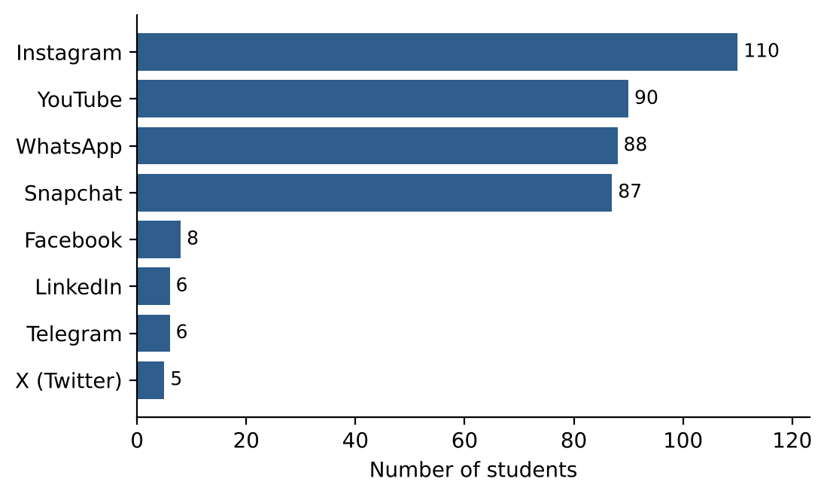
Fig No. 6.1 Most used social media platform (n = 400)
Instagram is the most used platform (110 students, 27.5%), followed by YouTube (90), WhatsApp (88) and Snapchat (87); these four platforms account for 93.75% of the responses.
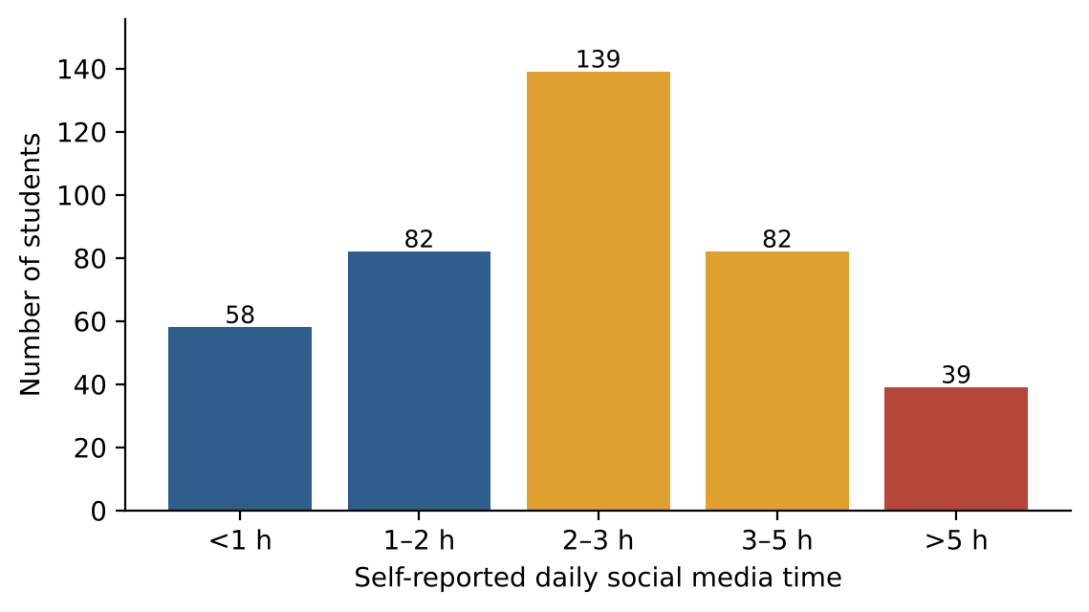
Fig No. 6.2 Self-reported daily social media time (n = 400)
The most common answer is 2–3 hours per day (139 students, 34.75%). 39 students (9.75%) report more than 5 hours.
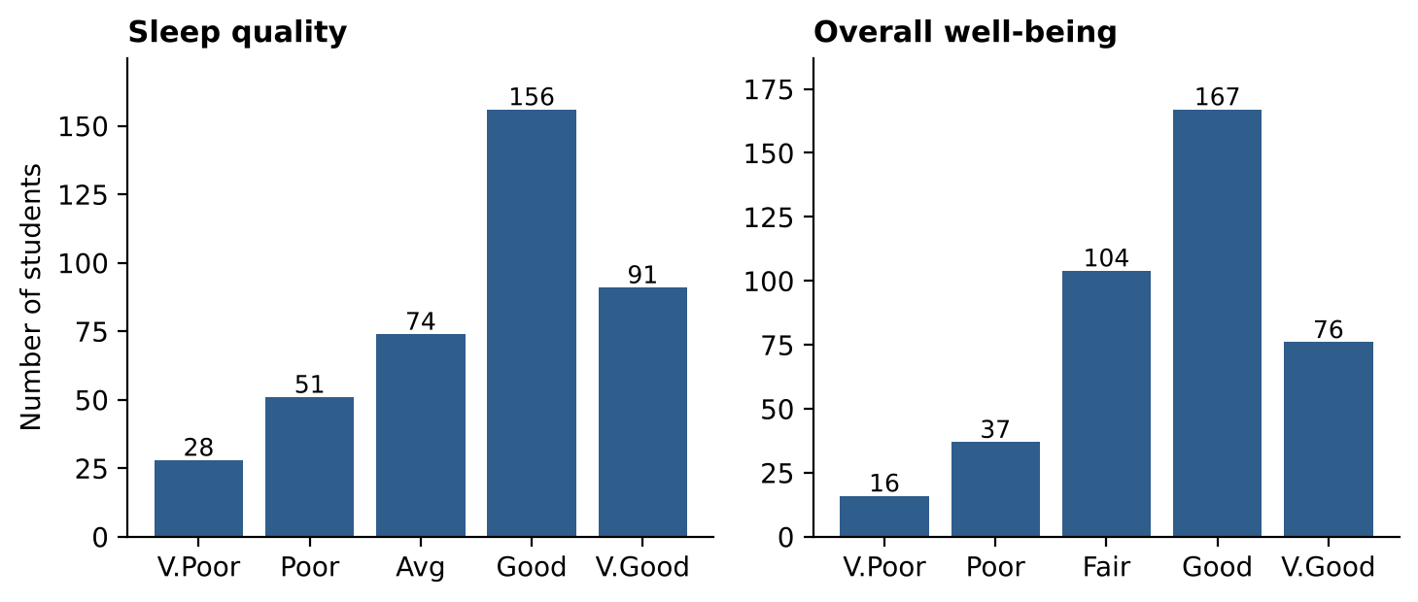
Fig No. 6.3 Sleep quality and overall well-being
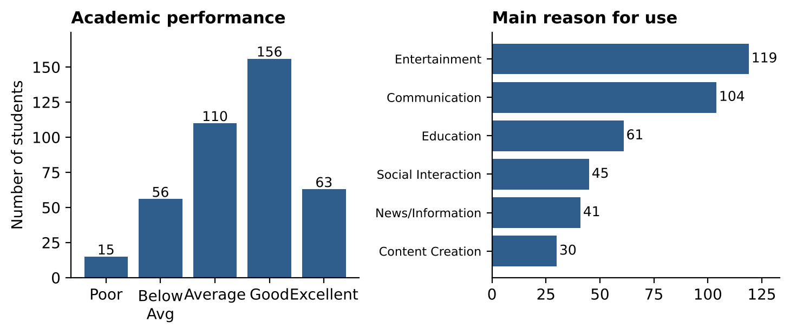
Fig No. 6.4 Academic performance and main reason for using social media
Most students rate their sleep as good or very good (61.75%), their well-being as good or very good (60.75%) and their academic performance as good or excellent (54.75%). Entertainment (119) and communication (104) are the main reasons for use. 204 students (51.0%) use social media within 30 minutes before going to sleep, and 202 (50.5%) have not tried to reduce their usage.
6.1.5 Statistical analysis
statistical_analysis.py uses a significance level of 0.05. Because almost all survey variables are categorical or ordinal, only one variable (Age) is numeric; therefore Pearson correlation could not be calculated and Spearman rank correlation was used for the ordinal variables.
• Descriptive statistics: Age mean 20.44, standard deviation 2.20, range 17–24; frequency tables for all categorical variables.
• Spearman correlation (11 ordinal variables): all coefficients are weak (|ρ| < 0.20). The largest are between checking frequency and discomfort without access (ρ = 0.186), checking frequency and study distraction (ρ = 0.139) and checking frequency and negative mood (ρ = 0.130).
• Covariance: computed for the same numeric/ordinal variables and saved in Covariance.xlsx.
• Independent-samples t-test: mean age of female and male students: t = 0.0369, p = 0.9706, so no significant difference.
Table 6.2 Chi-square tests of independence
Variable 1 | Variable 2 | χ² | df | p-value | Result (α = 0.05)
Daily_​Social_​Media_​Time | Academic_​Performance | 10.137 | 16 | 0.8594 | Not significant
Daily_​Social_​Media_​Time | Sleep_​Quality | 21.861 | 16 | 0.1477 | Not significant
Daily_​Social_​Media_​Time | Overall_​Well_​Being | 15.798 | 16 | 0.4671 | Not significant
Check_​Frequency | Study_​Distraction_​Frequency | 23.657 | 16 | 0.0973 | Not significant
Social_​Media_​While_​Studying | Academic_​Performance | 18.726 | 16 | 0.2831 | Not significant
Social_​Media_​Before_​Sleep | Sleep_​Quality | 1.448 | 4 | 0.8358 | Not significant
Main_​Usage_​Reason | Academic_​Performance | 14.765 | 20 | 0.7897 | Not significant
Most_​Used_​Platform | Academic_​Performance | 22.425 | 28 | 0.7613 | Not significant
Extended_​Scrolling | Overall_​Well_​Being | 17.171 | 16 | 0.3746 | Not significant
Tried_​To_​Reduce_​Usage | Usage_​Satisfaction | 9.330 | 8 | 0.3152 | Not significant

None of the ten Chi-square tests rejects the null hypothesis of independence. The closest to significance is checking frequency versus study distraction (p = 0.097). In this dataset, therefore, no statistically significant association was found between daily usage time and academic performance, sleep quality or well-being. The Chi-square result for usage time versus academic performance was independently re-computed from the cleaned data during report preparation (χ² = 10.137, df = 16, p = 0.8594) and matches the stored output.
6.1.6 Feature engineering
feature_engineering.py works on a separate copy of the cleaned data (the cleaned file is not modified) and increases the columns from 30 to 46 by creating 16 new features:
Table 6.3 Engineered features
Group | Features | Method
Ordinal scores | Check_​Frequency_​Score, Sleep_​Quality_​Score, Stress_​Score, Morning_​Check_​Score, Meal_​Check_​Score, Extended_​Scrolling_​Score, Well_​Being_​Score | Text answers (Never … Always, Very Poor … Very Good) mapped to 0–4
Numeric / binary | Daily_​App_​Checks_​Numeric, Daily_​App_​Checks_​Normalized, Social_​Media_​While_​Studying_​Binary, Delayed_​Study_​Binary, Social_​Media_​Before_​Sleep_​Binary, Tried_​To_​Reduce_​Usage_​Binary | App-check ranges converted to numbers and scaled; Yes/No answers converted to 1/0
Composite scores | Social_​Media_​Impact_​Score, Digital_​Dependency_​Score | Mean of related score columns (see Table 5.2)
Target | Social_​Media_​Usage_​Level | Low = under 1 h or 1–2 h; Moderate = 2–3 h or 3–5 h; Heavy = more than 5 h

The resulting target distribution is Moderate 221 (55.25%), Low 140 (35.00%) and Heavy 39 (9.75%), as shown in Figure 6.5, so the classes are imbalanced.
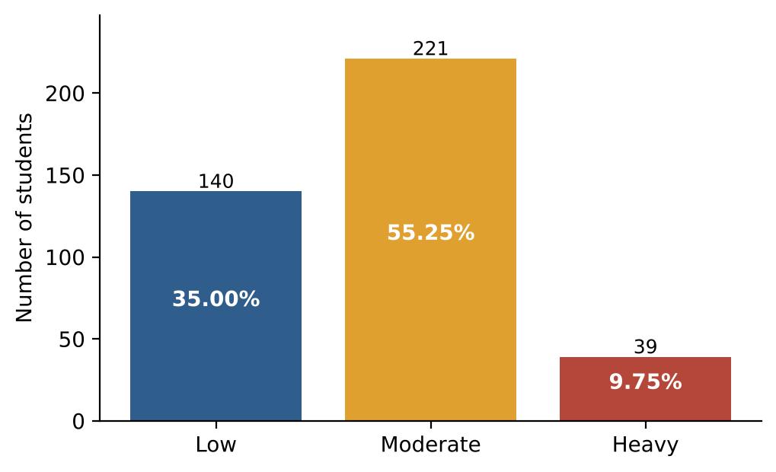
Fig No. 6.5 Distribution of the target variable Social_Media_Usage_Level
6.1.7 Feature selection
feature_selection.py first removes columns that must not be used as predictors: Daily_Social_Media_Time, because it directly defines the target (target leakage), and Timestamp. The remaining features are ranked by two methods, mutual information and random-forest importance. Each score is normalised to 0–1 and the average is the combined score. The twelve top-ranked features were selected (Figure 6.6).
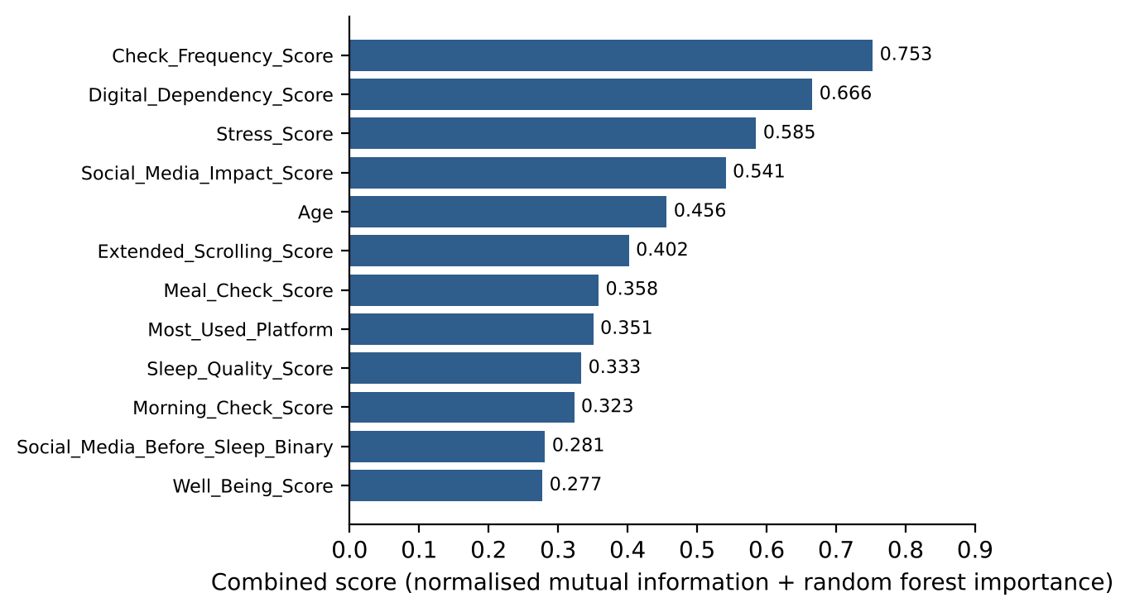
Fig No. 6.6 Combined feature-importance score of the 12 selected features
Check_Frequency_Score, Digital_Dependency_Score, Stress_Score and Social_Media_Impact_Score rank highest, so behavioural indicators of dependency and impact are more informative for the model than demographic variables.
6.1.8 Machine learning
machine_learning.py splits the 400 records into 320 training and 80 test records (80/20, stratified so that the Low, Moderate and Heavy proportions are preserved, random_state = 42). The test set contains 28 Low, 44 Moderate and 8 Heavy students. A scikit-learn Pipeline is used for every model: numeric features are median-imputed and standardised, the categorical feature (Most_Used_Platform) is imputed with the most frequent value and one-hot encoded. Because these steps are fitted only on the training data, no information from the test set leaks into training.
Table 6.4 Classification models
Model | Main settings
Logistic Regression | max_​iter = 2000
Decision Tree | max_​depth = 8
Random Forest | 200 trees, class_​weight = balanced
K-Nearest Neighbours | k = 5
Support Vector Machine | RBF kernel, class_​weight = balanced

6.1.9 Model evaluation
Table 6.5 Test-set performance (weighted averages, 80 test records)
Rank | Model | Accuracy | Precision | Recall | F1-score
1 | Logistic Regression | 56.25% | 49.58% | 56.25% | 51.60%
2 | K-Nearest Neighbours | 52.50% | 50.52% | 52.50% | 51.32%
3 | Random Forest | 46.25% | 45.70% | 46.25% | 45.83%
4 | Decision Tree | 43.75% | 41.56% | 43.75% | 42.62%
5 | SVM | 41.25% | 48.56% | 41.25% | 42.52%

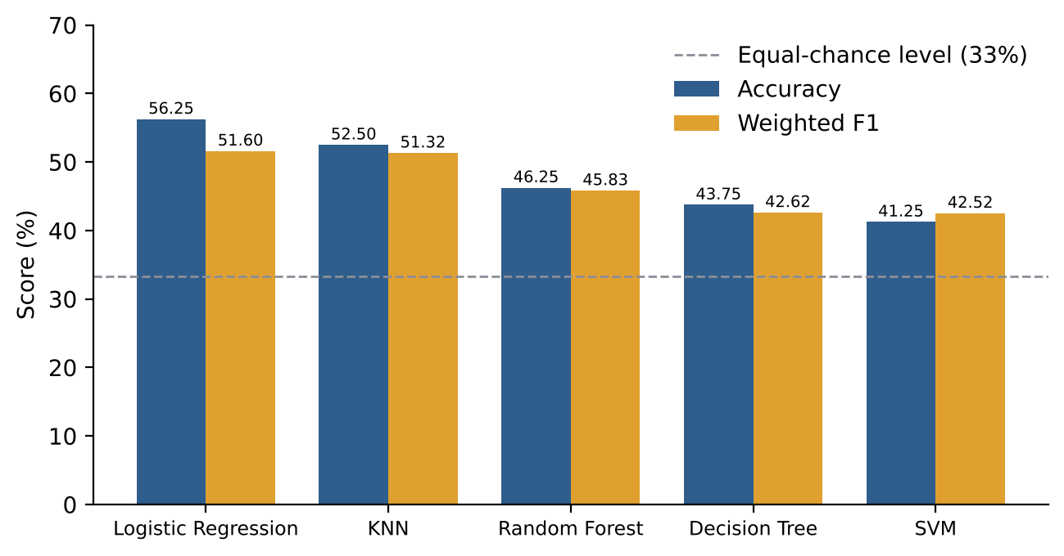
Fig No. 6.7 Accuracy and weighted F1-score of the five models
Models were ranked by weighted F1-score, which balances precision and recall across classes of different size. Logistic Regression was selected as the final model. Its confusion matrix and class-wise report are given below.
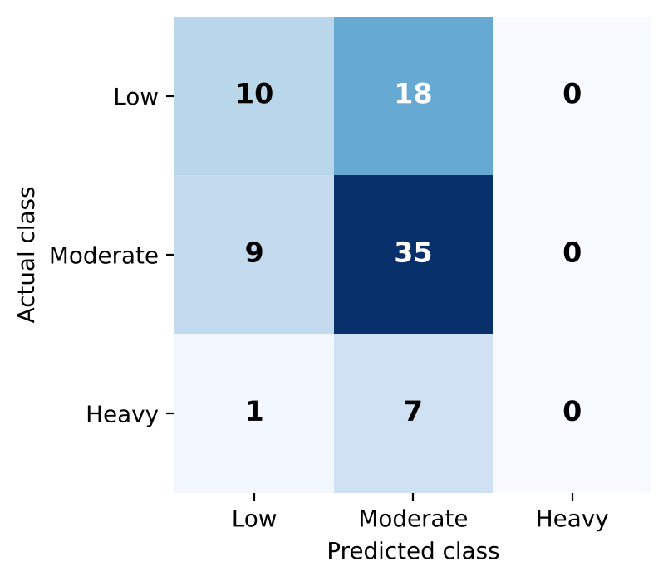
Fig No. 6.8 Confusion matrix of the Logistic Regression model (test set)
Table 6.6 Classification report of Logistic Regression
Class | Precision | Recall | F1-score | Support
Low | 0.50 | 0.36 | 0.42 | 28
Moderate | 0.58 | 0.80 | 0.67 | 44
Heavy | 0.00 | 0.00 | 0.00 | 8
Macro average | 0.36 | 0.38 | 0.36 | 80
Weighted average | 0.50 | 0.56 | 0.52 | 80

The model identifies Moderate users best (recall 0.80). It never predicts the Heavy class: all 8 Heavy students in the test set were classified as Low (1) or Moderate (7). Four of the five models have zero recall for Heavy, and the SVM recognises only one of eight Heavy students (recall 0.12). With 39 Heavy students in the whole data set, the minority class is too small for the models to learn from.
6.1.10 Final results
final_results.py gathers the findings into Final_Insights, Final_Model_Report and Final_Predictions for the dashboard. Key points: 55.25% of students are Moderate, 35.00% Low and 9.75% Heavy users; Instagram is the most used platform; Logistic Regression is the best of the five models with 56.25% accuracy; and 12 behavioural and demographic features were selected for prediction.
6.2 Front-end logic (UI rendering, state management)
app.py defines the paths of all data and result files relative to the project folder, loads them with cached helper functions, and renders the page chosen in the sidebar with a series of if/elif blocks. The cached loaders (@st.cache_data for Excel files, @st.cache_resource for the model) avoid re-reading files on every interaction. Streamlit re-runs the script on each user action and keeps widget values in its session, so no manual state handling is required. If a result file or the model is missing, the page shows a message instead of failing.
6.3 Backend logic (routes, controllers, business logic)
There are no web routes. The 'business logic' is the pipeline of ten scripts described above. Design decisions that guard the correctness of the results are: (i) the raw data is never modified; (ii) the target-defining column is excluded from the model inputs; (iii) imputation, scaling and encoding are fitted on the training data only through scikit-learn pipelines; (iv) a stratified split is used because of class imbalance; and (v) results are reported as obtained.
6.4 Database connectivity
Pandas (with openpyxl) reads and writes the Excel workbooks; paths are built from the project root with os.path so the project can be moved between computers. The trained pipelines are stored with Joblib and loaded by the dashboard.
6.5 API integration
No external API is called at run time. Data enters the system as an exported Google Sheet and downloaded Kaggle files, and the prediction page calls model.predict() and model.predict_proba() on the loaded scikit-learn pipeline.
6.6 Authentication & Authorization
The dashboard is a local, single-user tool and has no login. Privacy is addressed at data level: respondent names are removed during preprocessing, and the dashboard shows only the cleaned, anonymised data. Authentication would be required if the dashboard were hosted publicly.
CHAPTER 7
Features
7.1 List of main features
1. Automated data inspection and quality reporting for all datasets.
2. Integration workbook with variable mapping between survey and Kaggle datasets.
3. Automated cleaning with anonymisation of respondents.
4. Exploratory data analysis with charts for platforms, usage time, sleep, well-being and academic performance.
5. Statistical analysis: descriptive statistics, correlation, covariance, Chi-square and hypothesis tests.
6. Feature engineering of behavioural scores, including Digital Dependency and Social Media Impact scores.
7. Leakage-safe feature selection (mutual information + random-forest importance).
8. Training and comparison of five classification models with a full set of metrics.
9. Interactive Streamlit dashboard with six sections.
10. Prediction page that classifies a student profile as Low, Moderate or Heavy with class probabilities.
11. Final insights and recommendations page.
7.2 How each feature works
Table 7.1 Feature descriptions
Feature | User perspective | Technical description
Data quality reporting | Gets an Excel report of rows, types, missing values and duplicates | pandas summaries written to Data_​Inspection_​Report.xlsx and Data_​Quality_​Report.xlsx
Cleaning and anonymisation | Receives a clean dataset without names | Column renaming, Name removal, type conversion, text standardisation
EDA pages | Sees tables and charts of survey answers | Frequency tables from EDA_​Analysis.xlsx drawn with Matplotlib in Streamlit
Statistical analysis page | Sees correlation, covariance, t-test and Chi-square results with p-values | SciPy functions (chi2_​contingency, ttest_​ind, spearmanr) at α = 0.05
Feature engineering | Behaviour is summarised as scores (e.g. dependency score) | Ordinal mapping to 0–4 and mean of component columns
Model comparison page | Sees which model performs best and how | Five scikit-learn pipelines compared on accuracy, precision, recall and F1-score
Prediction page | Enters a student's behaviour scores and presses Predict; gets Low / Moderate / Heavy with probabilities | Inputs assembled in a one-row DataFrame, passed to the saved Logistic Regression pipeline
Final insights | Reads key findings and recommendations | Data from Final_​Insights.xlsx and the selected-feature list

CHAPTER 8
Testing
Testing of this project focuses on the correctness of the data pipeline, the saved model and the reproducibility of the reported results, because the application has no database, API or user accounts.
8.1 Functional testing (Postman not applicable)
Postman is used to test REST APIs. This project exposes no API, so it was not used. Instead, the modules were tested functionally by checking their outputs, and the dashboard pages by manual use.
8.2 Integration testing
Integration was tested by following the data from stage to stage and checking that each stage accepts the output of the one before: 400 rows are kept from the raw survey through cleaning, feature engineering and the ML-ready dataset; the column count changes as designed (31 → 30 → 46 → 13); and the saved model accepts the 12-column ML-ready input and returns predictions that match the stored test predictions.
8.3 Tools used for testing
• Python (py_compile) for syntax checks of all scripts; Pandas and openpyxl for checking dataset shapes and missing values.
• Joblib and scikit-learn to load the saved model and re-run predictions; SciPy to re-compute a Chi-square test.
• Manual testing of the Streamlit dashboard in a web browser.
8.4 Test cases and results
Table 8.1 Test cases and results
ID | Test case | Expected result | Actual result | Status
TC1 | Compile the 10 pipeline scripts and app.py | No syntax errors | All 11 files compile | Pass
TC2 | Cleaned_​Data.xlsx shape, missing values and anonymisation | 400 rows, 30 columns, 0 missing, no Name column | 400 × 30, 0 missing, Name column absent | Pass
TC3 | ML_​Ready_​Data.xlsx completeness | 400 rows, 13 columns, 0 missing values | 400 × 13, 0 missing | Pass
TC4 | Target leakage check | Daily_​Social_​Media_​Time and Timestamp are not model inputs | Neither column is present in ML_​Ready_​Data | Pass
TC5 | Target distribution adds up | Moderate + Low + Heavy = 400 | 221 + 140 + 39 = 400 | Pass
TC6 | Load saved Logistic_​Regression.pkl | Loads as a pipeline with classes Heavy, Low, Moderate | Loaded; classes = Heavy, Low, Moderate | Pass
TC7 | Predict on a valid input row | A class label and 3 probabilities summing to 1 | Label returned; probabilities sum to 1.0 | Pass
TC8 | Predict with a platform value 'Other' not seen in training | No error (unknown category ignored) | Prediction returned without error | Pass
TC9 | Reproduce reported accuracy from Test_​Set_​Predictions.xlsx | LR 56.25%, DT 43.75%, RF 46.25%, KNN 52.50%, SVM 41.25% | Identical values obtained | Pass
TC10 | Re-compute Chi-square (usage time vs academic performance) | χ² = 10.137, df = 16, p = 0.8594 | Identical values obtained | Pass
TC11 | Dashboard: each of the 6 sidebar sections opens without error | All pages render | [to be checked by the team after running the dashboard] | [Pass / Fail]
TC12 | Dashboard: Predict button with default inputs | Colour-coded result and probability table appear | [to be checked by the team after running the dashboard] | [Pass / Fail]

CHAPTER 9
Deployment
9.1 Steps to deploy
The application is run locally. Steps:
1. Install Python 3.9 or later.
2. Copy the project folder (src, data, models, outputs, streamlit) to the computer.
3. Install the required libraries: pip install pandas numpy matplotlib seaborn scipy scikit-learn openpyxl joblib streamlit.
4. (Only if outputs must be regenerated) run the scripts in this order from the project folder: data_inspection, data_integration, preprocessing, eda, statistical_analysis, feature_engineering, feature_selection, machine_learning, model_evaluation, final_results.
5. Start the dashboard from the project folder with: streamlit run streamlit/app.py.
6. Open the local address shown in the terminal (normally http://localhost:8501) in a web browser.
Note: because the project folder is itself called 'streamlit', start the dashboard with the 'streamlit run' command as above; running 'python -m streamlit' from the project folder can fail because the folder name hides the installed package.
9.2 Environment configuration
• All file paths are computed relative to the project root, so no configuration file or environment variable is needed.
• The folder structure (data/raw, data/interim, data/processed, outputs/, models/) must be kept unchanged.
• The trained models were saved with a particular scikit-learn version; the same major version should be used to load them, or machine_learning.py should be re-run to regenerate them.
• The project does not currently include a requirements.txt; creating one (pip freeze) is recommended for reproducible set-up and is required for cloud hosting.
9.3 Hosting of frontend and backend
Frontend and backend are one Streamlit process, so a single host is sufficient. The dashboard has not been deployed publicly [team to confirm]. If hosting is required, the project can be pushed to a GitHub repository and deployed on Streamlit Community Cloud, or run in a container on a cloud virtual machine. Before public hosting, a login or access control should be added and the data re-checked for privacy.
CHAPTER 10
Challenges & Limitations
10.1 Issues faced during development
• Different dataset schemas: the survey and Kaggle datasets have different columns and describe different observations, so they could not be merged into one table.
• Text-based answers: most survey answers are categories (e.g. 'Sometimes', '21–50') that had to be converted into ordered numeric scores.
• Target leakage: the Low/Moderate/Heavy target is defined from the daily usage time, which therefore cannot be used as an input.
• Class imbalance: only 39 of 400 students (9.75%) are Heavy users.
• Weak relationships: the statistical tests found no significant associations, so the classification task is difficult.
• Incomplete mappings in feature engineering: some text-to-number mappings did not cover every answer in the survey (see Section 10.3).
10.2 Solutions applied
• The datasets are kept side by side in an integration workbook with a variable mapping; the survey is the primary dataset.
• Ordered mappings (0–4 scores) and Yes/No conversion were written for the survey questions.
• Daily_Social_Media_Time and Timestamp were excluded from the model inputs.
• A stratified train/test split, class weights for Random Forest and SVM, and weighted metrics were used to deal with imbalance.
• Missing values created during feature engineering are filled by median / most-frequent imputation (during feature selection, and again inside the scikit-learn pipelines, where it is fitted on the training data only).
• Model results were reported as obtained, without artificially improving them.
10.3 Current limitations or known bugs
• Modest model performance: the best model reaches 56.25% accuracy and 51.60% weighted F1 on only 80 test records; the estimate is therefore uncertain.
• Heavy class not detected: the best model never predicts Heavy (recall 0 for 8 students).
• No significant associations: all ten Chi-square tests and the t-test have p > 0.05, so the data gives no statistical evidence of the relationships studied.
• Not population-level: the survey data contains simulated responses in addition to the originally submitted response, so the results demonstrate the workflow and should not be presented as statistics of the student population.
• Incomplete score mappings: in Feature_Engineered_Data.xlsx, Check_Frequency_Score is empty for 125 students because the answers 'Occasionally' and 'Very Frequently' are not in the mapping; Social_Media_While_Studying_Binary and Delayed_Study_Binary are empty for all 400 students because Yes/No mapping was applied to frequency-scale answers (Never … Always); and Daily_App_Checks_Numeric is empty for 356 students. These gaps are filled by imputation before modelling, but extending the mappings could improve the features.
• Input scale on the Prediction page: the sliders allow values up to 5, whereas the training scores range from 0 to 4 (Check Frequency 1–4), so the user should enter values in the training range.
• Dashboard tool: the abstract proposed a Power BI dashboard; the delivered dashboard is built in Streamlit.
• Secondary datasets: the Kaggle datasets are used only as contextual references and are not merged into the model data.
CHAPTER 11
Future Enhancements
11.1 Planned features
• Extend the ordinal mappings so that no engineered feature is empty, then re-run feature selection and model training.
• Collect more genuine survey responses, especially from heavy users, to reduce class imbalance and allow a larger test set.
• Apply cross-validation, hyper-parameter tuning and imbalance techniques (e.g. SMOTE or class weights for all models) and report confidence intervals.
• Make the Prediction page accept the raw survey answers and compute the scores automatically, with input ranges matching the training data.
• Add a download button for reports and charts on the dashboard.
• Add a Power BI version of the dashboard, as proposed in the abstract.
11.2 Possible integrations or optimizations
• Read responses directly from Google Sheets so the pipeline updates automatically.
• Use the Kaggle datasets for comparative analysis (e.g. addiction level or lifestyle indicators against survey findings).
• Deploy the dashboard on Streamlit Community Cloud or a container with login protection.
• Add a requirements.txt, automated tests and a CI pipeline to run them.
• Store data in a database (e.g. SQLite or PostgreSQL) if the volume of responses grows.
CHAPTER 12
Conclusion
12.1 Summary of the project
The Survey Data Analysis Tool is an end-to-end Data Science project that takes raw survey responses on student social media usage through inspection, integration, preprocessing, exploratory analysis, statistical testing, feature engineering and selection, and machine learning, and presents the results in an interactive Streamlit dashboard.
12.2 What was achieved
• A 400-response survey and two Kaggle datasets were inspected, organised and cleaned, with respondent names removed.
• The data was explored and tested statistically; no significant associations were found at the 5% level.
• Sixteen features were engineered and twelve selected without target leakage.
• Five classifiers were trained and compared; Logistic Regression was selected with 56.25% accuracy and 51.60% weighted F1-score.
• An interactive dashboard with six sections and a prediction page was built.
• Limitations such as class imbalance, simulated responses and incomplete mappings were identified openly.
The classification results are modest and should be interpreted as a demonstration of a sound workflow on the available data rather than as a validated predictor of student behaviour.
12.3 Skills learned during development
• Data cleaning and preprocessing of survey data with Pandas.
• Exploratory and statistical analysis (Chi-square, t-test, correlation) and interpreting non-significant results.
• Feature engineering, feature selection and recognising target leakage.
• Building and comparing classification models with scikit-learn pipelines, and reading confusion matrices and class-wise metrics.
• Building a dashboard with Streamlit, and documenting a project report.
• Team work and version management of a multi-stage project.
CHAPTER 13
References
1. Pedregosa, F. et al., 'Scikit-learn: Machine Learning in Python', Journal of Machine Learning Research, vol. 12, pp. 2825–2830, 2011.
2. McKinney, W., 'Data Structures for Statistical Computing in Python', Proceedings of the 9th Python in Science Conference, 2010.
3. Virtanen, P. et al., 'SciPy 1.0: Fundamental Algorithms for Scientific Computing in Python', Nature Methods, vol. 17, pp. 261–272, 2020.
4. Hunter, J. D., 'Matplotlib: A 2D Graphics Environment', Computing in Science & Engineering, vol. 9, no. 3, pp. 90–95, 2007.
5. Streamlit documentation: https://docs.streamlit.io
6. Scikit-learn documentation: https://scikit-learn.org/stable/user_guide.html
7. Pandas documentation: https://pandas.pydata.org/docs/
8. SciPy statistics documentation: https://docs.scipy.org/doc/scipy/reference/stats.html
9. Kaggle datasets used: social media addiction dataset and student lifestyle dataset, https://www.kaggle.com [add exact dataset titles/URLs]
10. Google Forms / Google Sheets: https://workspace.google.com
CHAPTER 14
Appendices
14.1 Screenshots of the app
[Insert dashboard screenshots here: Overview, Survey & EDA, Statistical Analysis, Machine Learning, Prediction (with a result), Final Insights. Run: streamlit run streamlit/app.py]
14.2 Sample code snippets
A. Target creation (feature_engineering.py)
def create_usage_level(value):
text = str(value).strip().lower()
if 'less than 1 hour' in text or '1–2 hours' in text or '1-2 hours' in text:
return 'Low'
if '2–3 hours' in text or '2-3 hours' in text or '3–5 hours' in text or '3-5 hours' in text:
return 'Moderate'
if 'more than 5 hours' in text:
return 'Heavy'
return np.nan

B. Preprocessing pipeline and models (machine_learning.py)
numeric_pipeline = Pipeline([('imputer', SimpleImputer(strategy='median')),
('scaler', StandardScaler())])
categorical_pipeline = Pipeline([('imputer', SimpleImputer(strategy='most_frequent')),
('onehot', OneHotEncoder(handle_unknown='ignore'))])
preprocessor = ColumnTransformer([('numeric', numeric_pipeline, numeric_features),
('categorical', categorical_pipeline, categorical_features)])

X_train, X_test, y_train, y_test = train_test_split(
X, y, test_size=0.20, random_state=42, stratify=y)

models = {
'Logistic_Regression': LogisticRegression(max_iter=2000, random_state=42),
'Decision_Tree': DecisionTreeClassifier(random_state=42, max_depth=8),
'Random_Forest': RandomForestClassifier(n_estimators=200, random_state=42, class_weight='balanced'),
'KNN': KNeighborsClassifier(n_neighbors=5),
'SVM': SVC(kernel='rbf', random_state=42, class_weight='balanced'),
}

C. Prediction (streamlit/app.py)
model = joblib.load(MODEL_PATH)
prediction = model.predict(input_data)[0]
probabilities = model.predict_proba(input_data)[0]

14.3 Installation/setup instructions
See Chapter 9: install Python, install the libraries with pip, keep the folder structure and run 'streamlit run streamlit/app.py'.
14.4 User manual or guide
1. Start the dashboard and open the displayed address in a browser.
2. Use the sidebar menu 'Select Section' to move between Overview, Survey & EDA, Statistical Analysis, Machine Learning, Prediction and Final Insights.
3. On Prediction, enter the student's age, most used platform and the behaviour scores (use the same 0–4 scales as in Table 5.2), choose whether social media is used before sleep, and press 'Predict Usage Level'.
4. Read the predicted level (Low, Moderate or Heavy) and the class probabilities. The result is an indicative classification, not a medical or psychological diagnosis.
14.5 Certifications
[Add team members' course/ certification certificates here, if required by the department]

